|  |
| --- |
| **ABYSS Project** |
| Multi-disciplinary Project – 2006 IS1 v1.0 |
|  |
| It is the complete Installation step by step documentation for ActiveDirectory and Oracle. |
|  |
| **Groupe n ???** |
| **5/5/2007** |
|  |

**TODO *(pour ceux que ça intéresse)***

1. Revoir la mise-en-page (même si j’ai essayé d’en faire un max au fur et à mesure) avec une vrai page de garde (celle-ci est un template de Word2007).

Kevin doit m’envoyer les fichiers Photoshop du design de l’application et je me baserai dessus pour faire un truc sympa.

1. Une relecture avec une anglophone de toute la doc pour l’orthographe/tournures de phrases (je m’en chargerai avec ma môman).
2. Et le blabla de présentation/introduction à étayer (si bien sur nous avons autre choses à dire).

- skar -

Table of Contents

Introduction 4

About Abyss Client 4

Windows Server 2003 5

Installation 5

Configuration 5

Computer Name and DNS suffix 5

TCP/IP configuration 7

DNS Service 8

Installation 8

Configuration 13

Active Directory 15

Installation 15

Configuration 18

Installation checking 19

Oracle 20

Installation 20

MMC Console 24

Installation 24

Creation 24

Schema Permissions 25

Grant Schema Permissions 25

Allow Schema Update 27

Active Directory Anonymous Operation 28

Oracle Context 30

View Advanced Features 30

Creation 30

Oracle Context’s checkout 33

Administrator rights on Oracle Context 34

Anonymous Logon on OracleContext 36

????? 38

Database Configuration 39

# Introduction

Welcome to the official documentation of Abyss Client. Abyss System thanks you for using this product and hope that your experience will be rewarding and constructive. This documentation explains in detail the installation of the architecture needed for a complete use of Abyss Client. If you have any questions and do not find your answer or for any recommendation, please report to the end of this document and contact us.

# About Abyss Client

Abyss Client is the all in one administrative application for industrial production server based on Windows 2003 Server R2 and Oracle Database 10g R1/R2.

If you have just acquiring Abyss Client and want to use it, follow the guide step by step to obtain an operational server with Active Directory and Oracle Database in function.

Abyss Client can be executed directly from your server or from a distant client (on the same local network of your server) who have administrative rights to connect on the server.

*[ bla bla bla ]*

# Windows Server 2003

## Installation

First at all you need a fresh new copy of Windows 2003 Server activate and up to date.

This documentation have been made with a copy of Windows 2003 Server Enterprise Edition and is certified working with it. It works too with Windows 2003 Server Standard Edition and Windows 2003 Server Datacenter edition (compatibility with Active Directory).

The installation of Windows 2003 Server is not detailed in this documentation. For further information, please report to your product guide or contact [Microsoft Support](http://support.microsoft.com). *D’une maniére générale* follow the default instructions. Indeed, Abyss Client doesn’t need any specific configurations and works with any languages.

Once *(une fois)* your server launched, check your computer name and configure your network setting.

## Configuration

### Computer Name and DNS suffix

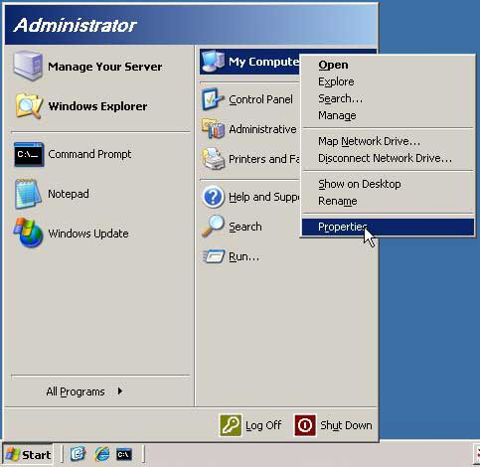

First, click on your “start” button, right click on “My Computer” and left click on “Properties”.

You are now on the “System Properties”.

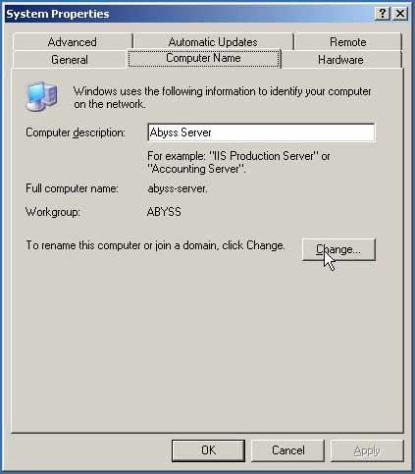

To see your computer name, click on the “Computer Name” tab.

Here you can modify your “Computer description” (not an essential’s parameter) and check the “Computer Name” and “Workgroup”.

To modify these parameters, click on the button “Change…” to access to the “Computer Name Changes” windows.

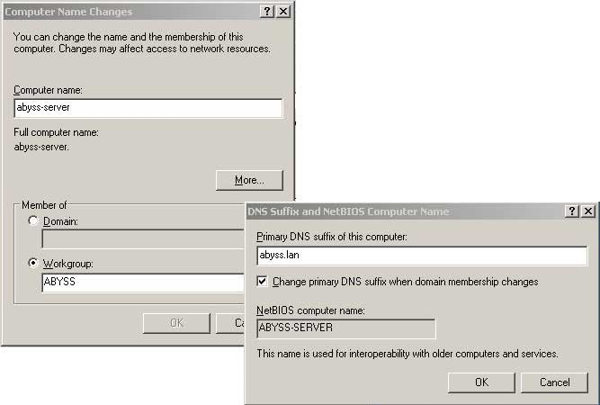

When you have finished, validate and close the windows.

Your computer must have to reboot before continuing the installation.

If your server is the Primary DNS of your network, click on “More…” to specify the DNS suffix of your network (not pre-configured).

Take care because you will not be able to modify these after the DNS Server Installation.

### TCP/IP configuration

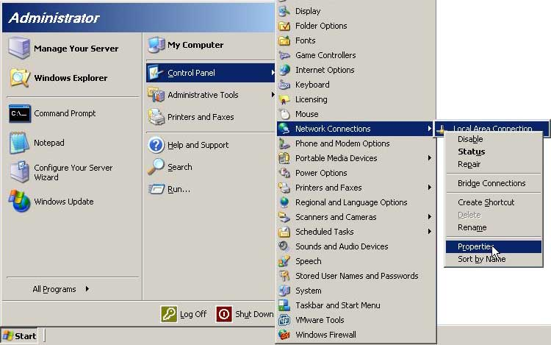

Your server needs to have a static IP to be DNS Server.

Click on “Start” button; go to “Control Panel” and click on “Network Connections”.

Edit properties of your primary Network Connection and attribute a valid local static IP and subnet mask.

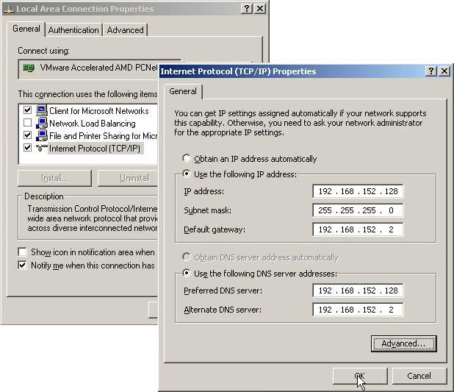

For the DNS Server Addresses, enter for Preferred Server your static IP and for alternate, another DNS server’s IP or your router’s IP.

Click OK to validate your configuration and reboot your system.

# DNS Service

## Installation

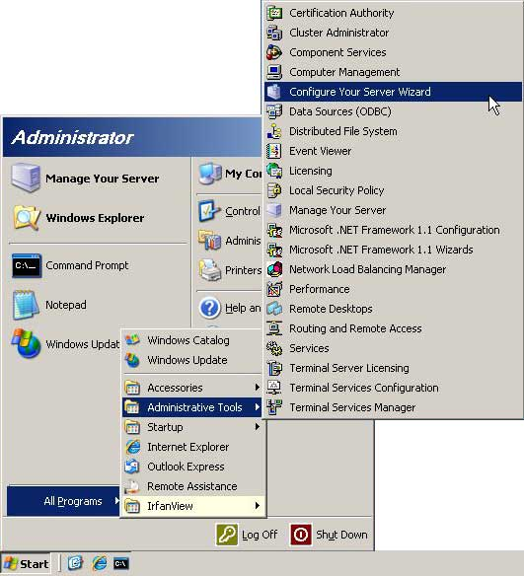

In “Administrative Tools” click on “Configure Your Server Wizard”.

Click “Next” twice and wait during it is charging.

The DNS Service Installation can begin…

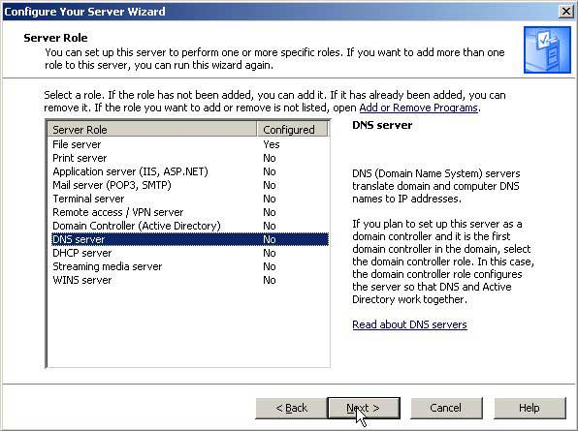

At first, select the Server Role you want to install by clicking on “DNS server”.

Here, check that it is not configured (value = “No”).

Then click twice on “Next” to launch the installation (you need Windows 2003 Server CD Installer).

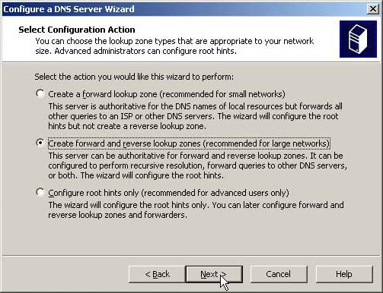

After few minutes, you will be able to configure your DNS Server.

At first, select “Create forward and reverse lookup zones” (read the description for further information) and Next.

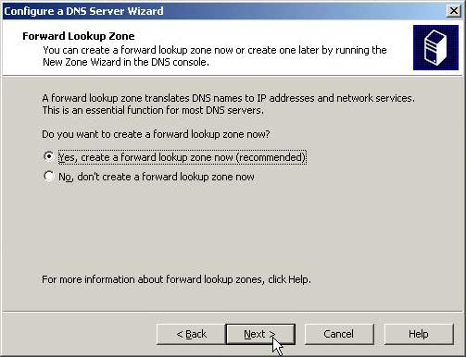

To create a Forward Lookup Zone now, click on “Yes, create a forward lookup zone now” and Next.

You can create it later by running the “New Zone Wizard” in the DNS console.

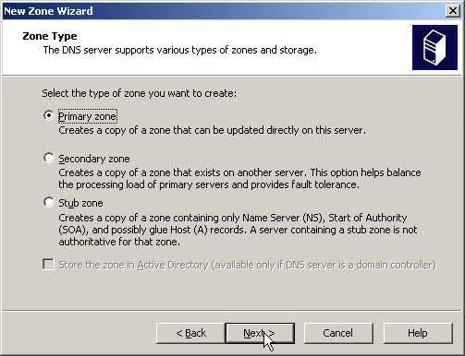

Here, we are installing the main DNS Server, so select “Primary zone”, and Next.

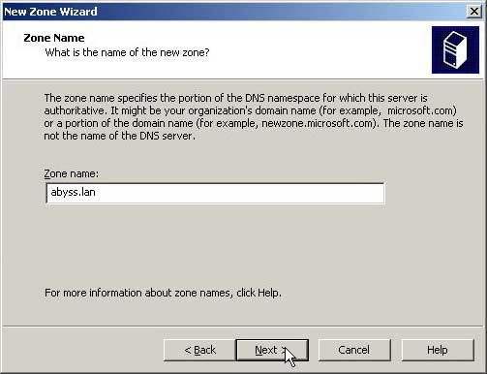

Specify for “Zone Name” your DNS suffix and Next.

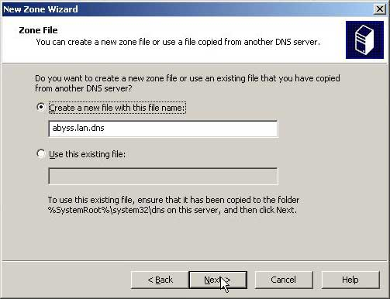

Click Next to validate the zone file’s creation.

If you already have one from a previous installation, copy this file on the specified folder and select it.

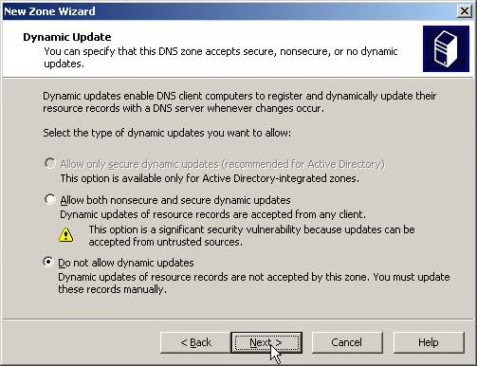

Do not allow now dynamic updates and validate by Next. We will update this at the end of the installation.

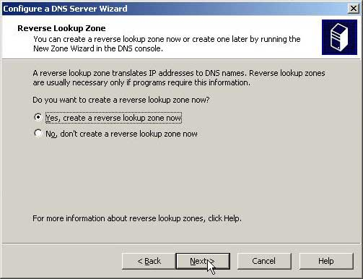

Click on Next to validate the reverse lookup zone creation.

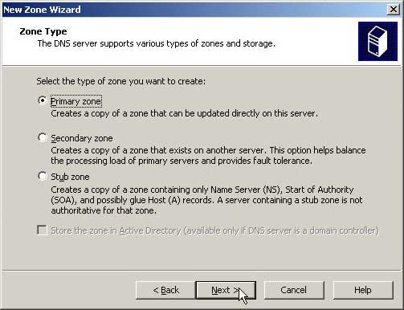

Here, we are installing the main DNS Server, so select “Primary zone”, and Next.

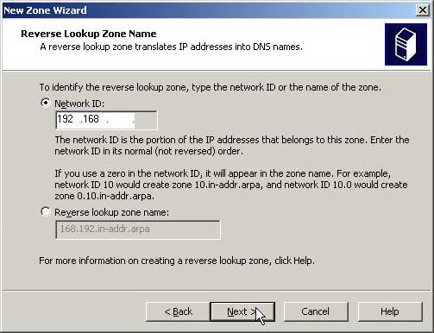

Enter the first part of your IP for the Network ID and Next.

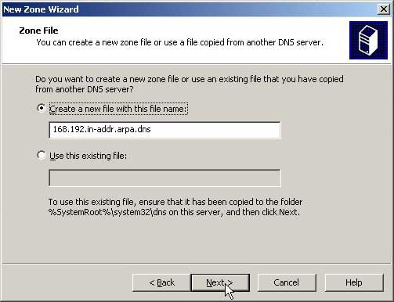

Click on Next to validate the zone file’s creation.

If you already have one from a previous installation, copy this file on the specified folder and select it.

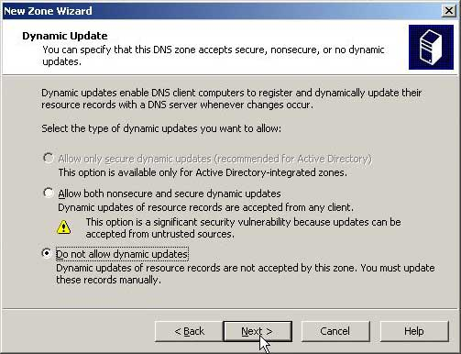

Do not allow dynamic updates and validate by Next. We will update this at the end of the installation.

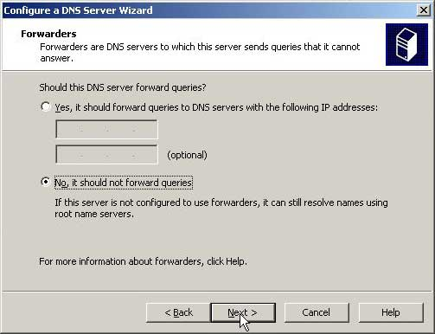

On the next windows, click “Finish”.

Your DNS Server is now fully installed.

Do not forward queries and validate by Next.

## Configuration

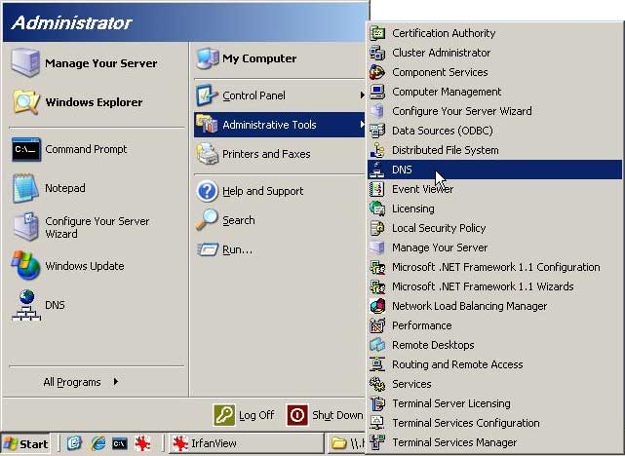

Now, we are allowing dynamic updates.

At first, launch the DNS Consol in the Administrative Tools.

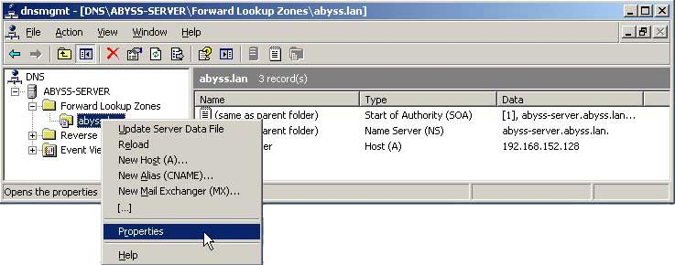

Develop “Forward Lookup Zones” and your DNS.

Make a Right click and click on “Properties”.

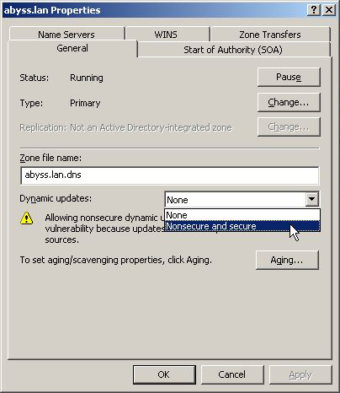

Then, replace the value of Dynamic updates by “Nonsecure and secure” in General tab.

We will secure it later after the installation of Active Directory.

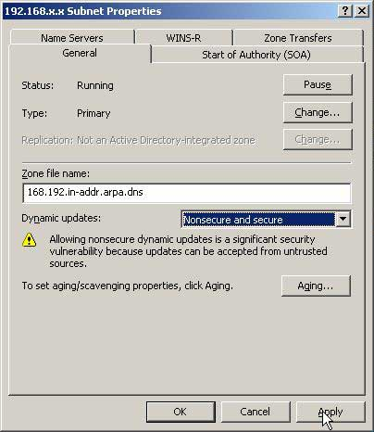

Do the same for the “Reverse Lookup Zones”.

Dynamic updates are allowed and your DNS Server is now fully configured.

Nonsecure dynamic update will be removing after the installation of Active Directory.

# Active Directory

## Installation

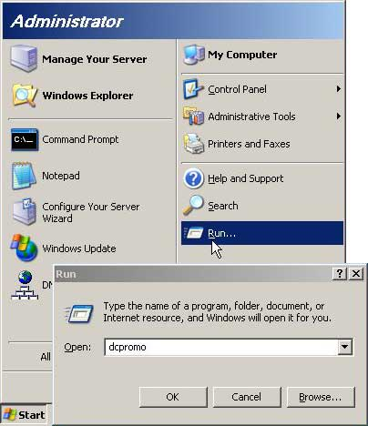

To launch the installation, click on “Start” button, “Run”, write “dcpromo” then validate.

It opens the “Active Directory Installation Wizard”.

Click twice on Next

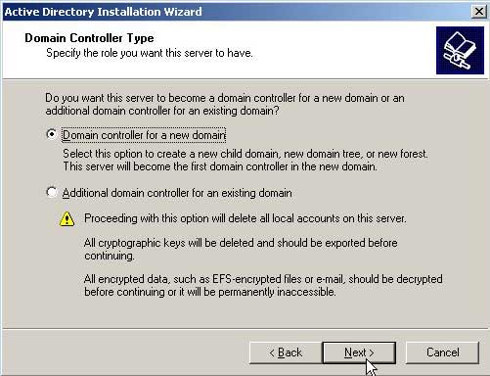

Be sure to select “Domain controller for a new domain” then Next.

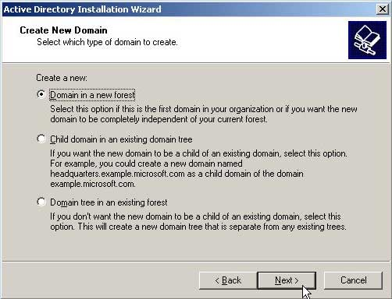

Select “Domain in a new forest” then Next.

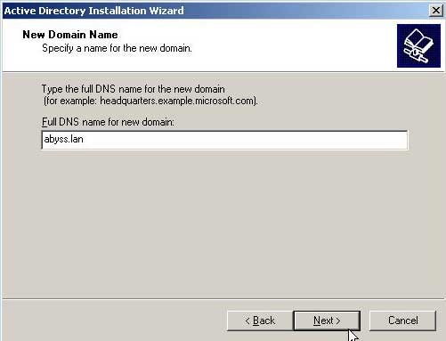

Enter the DNS name then Next.

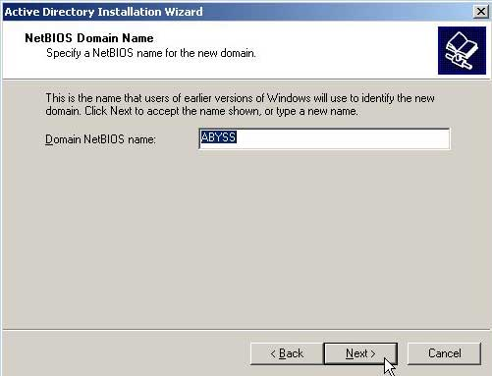

Verify the Domain NetBIOS name then Next.

Next windows specify the Database and Log Folder and the Shared System Volume.

Validate the default value by clicking on Next.

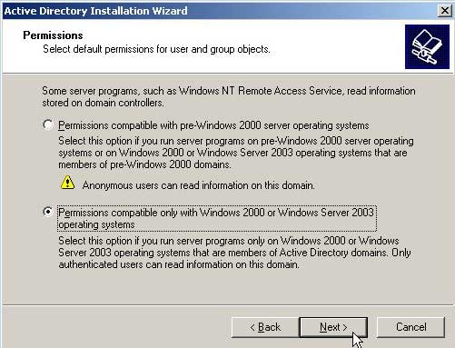

Select permissions for user and group objects likes on this picture.

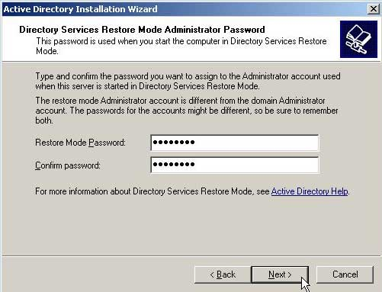

Choice a Restore Administrator Password, click on Next and validate the last Summary.

The installation will be finish after a reboot.

## Configuration

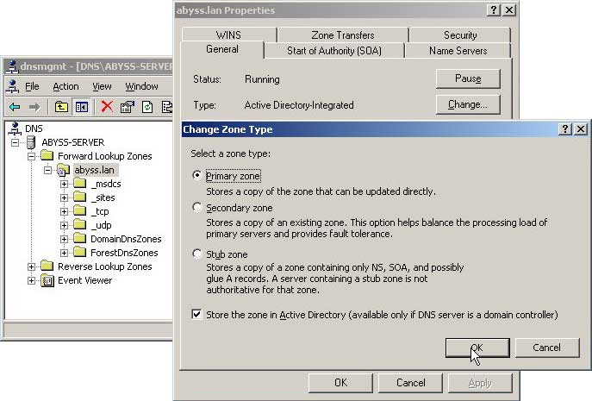

Now we are increasing the security level of the DNS Server.

First, launch DNS Consol in Administrative Tools.

Develop “Forward Lookup Zones” and your DNS Name.

Make a Right click and click on “Properties”.

In your DNS properties, click on “Change…” and check “Store the zone in Active Directory”.

Validate and change the value of Dynamic updates to “Secure only”.

Do the same with the “Reverse Lookup Zones”.

Your DNS Server is now secure.

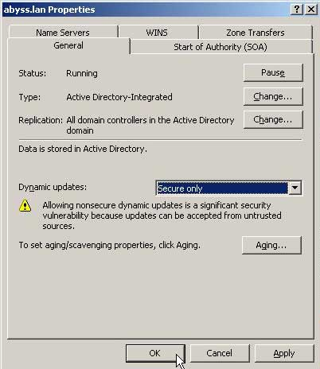

## Installation checking

*Vérification de l’installation d’Active Directory*

Go to the DNS consol and develop “Forward Lookup Zones”, your DNS server and “_tcp”. Verify that “enregistrements de ressources SRV” are present.

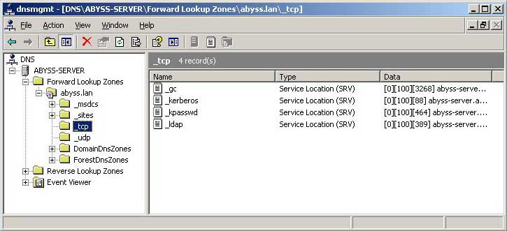

Then, click on Start button and “Run…”. Copy “%systemroot%\SYSVOL” and “%systemroot%\NTDS” to verify the creation of those folders.

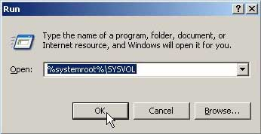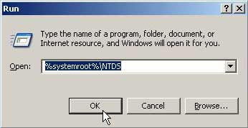

To finish, launch the console: “Start”, “Run…” and “cmd” to use the command “net share”. Be sure that “SYSVOL” folder is share.

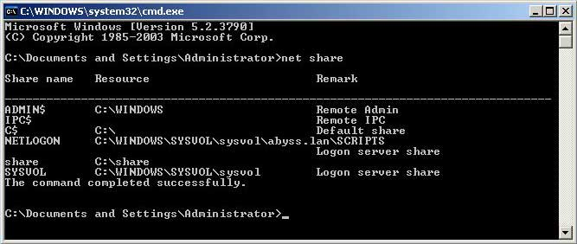

# Oracle

## Installation

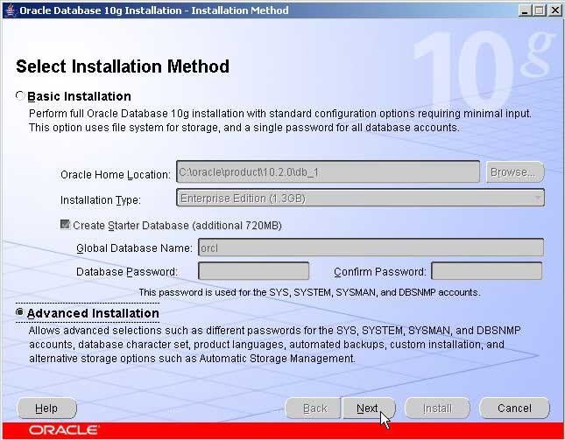

Insert the CD, the installation will launch automatically.

To begin, choice “Advanced installation”.

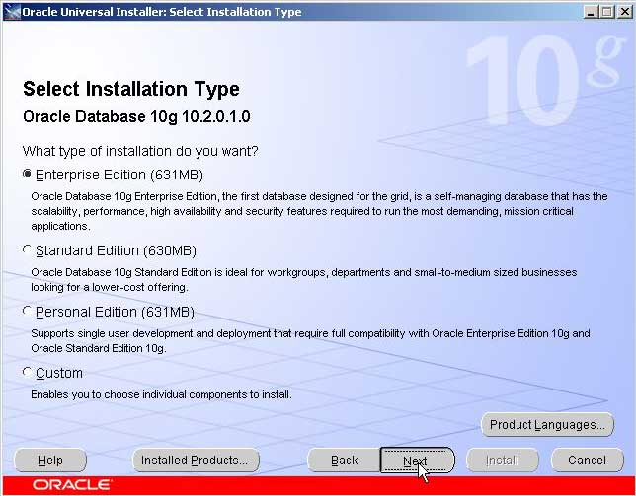

Then, select “Entreprise Edition”.

You need to have 631MB free space to complete the installation.

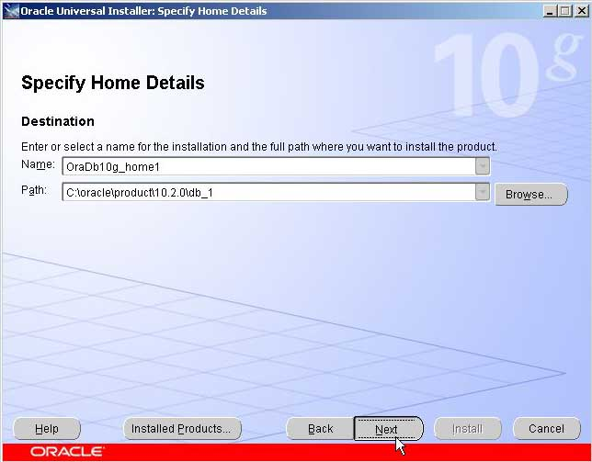

Let the default path and name. Click Next.

Then, you have to wait few minutes for the prerequisite checks.

If all is done, validate and continue the install by clicking on Next.

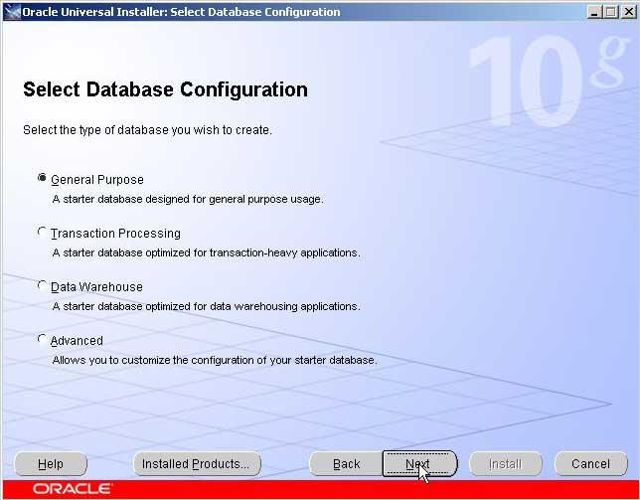

Now, you have to choice a Database Configuration.

Select the “General Purpose” and Next

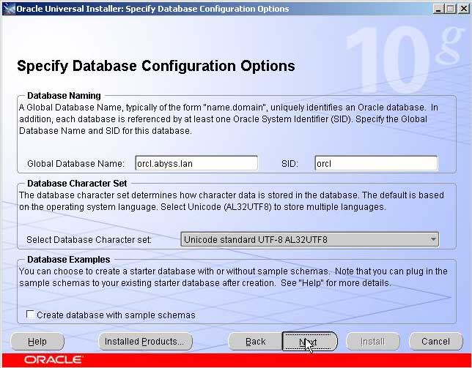

Enter the Global Database Name and let the default SID.

Change the Character set to “Unicode standard UTF-8 AL32UTF8” and Next.

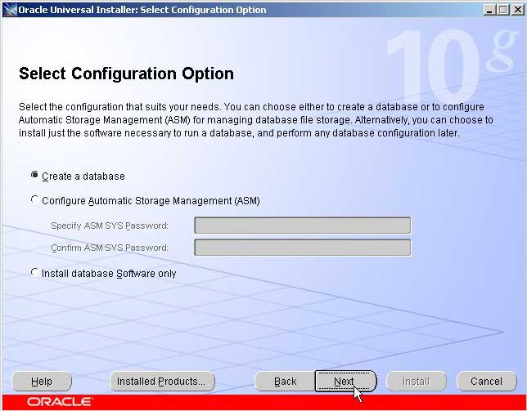

Be sure that “Create a database” is checked and validate.

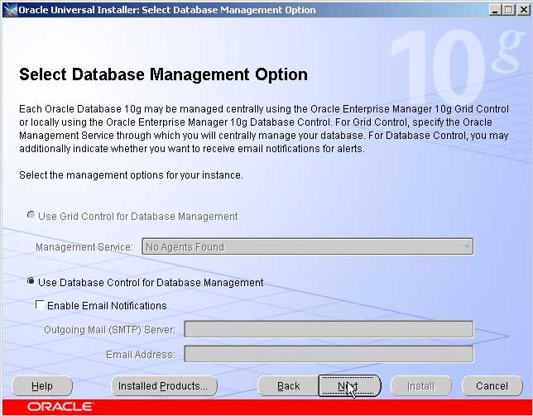

Be sure that “Create a database” is checked and validate.

Do not enable Automated backups.

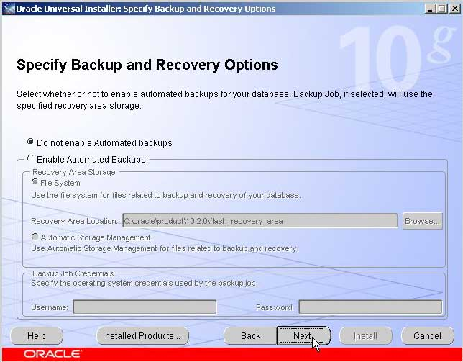

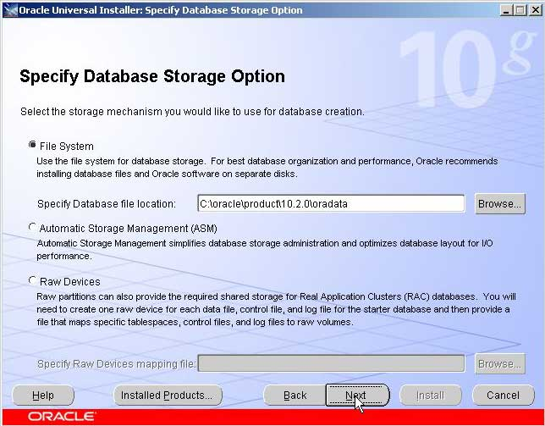

Select the “File System” storage mechanism. Let the default Database file location.

And validate by Next.

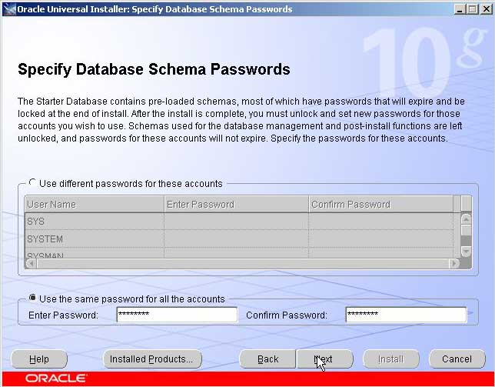

Specify passwords for privileged users. Here we choice to use the same password for all the accounts (you can modify passwords after).

Validate the Summary on the next windows. The Database is installing (it make take few minutes).

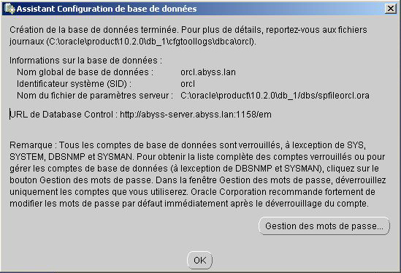

At the end, note information about your Database, validate the last summary and exit the program.

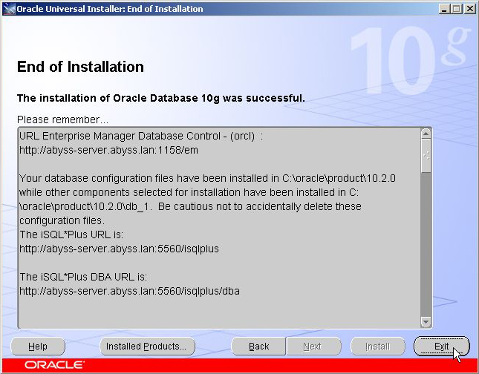

Oracle 10g is now fully installed.

We can configure the integration of Oracle in Active Directory.

# MMC Console

## Installation

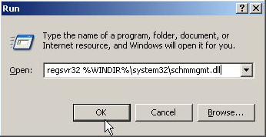

MMC console allow Administrator to do a lot of things like granted Schema’s Permissions.

To install it, launch the console: “Start”, “Run…” and “regsrv32 %WINDIR%\system32\schmmgmt.dll”.

Validate the popup, the installation is done.

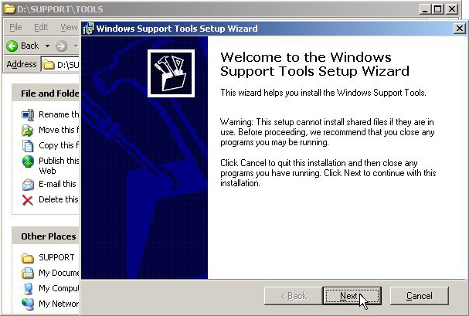

Then, you need the ADSI MMC Console.

Insert you Windows 2003 Server CD and execute “.exe” on “D:\SUPPORT\TOOLS”.

Click twice on next to launch the finish the install.

## Creation

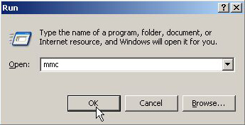

To create your own MMC Console, launch the console: “Start”, “Run…” and “mmc”.

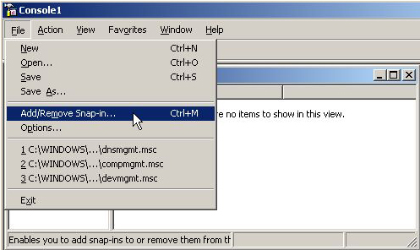

To Add or Remove view, click on “Add/Remove Snap-in…” (or Ctrl+M).

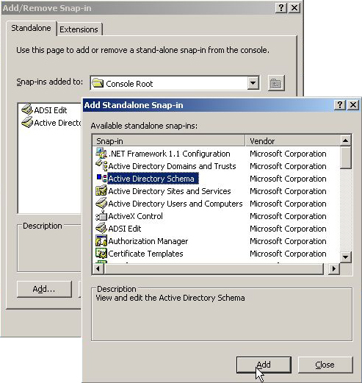

In the list of components, add:

* ADSI Edit (previously installed)
* Active Directory Users and Computers
* Active Directory Schema

Validate and save your personal MMC Console.

# Schema Permissions

## Grant Schema Permissions

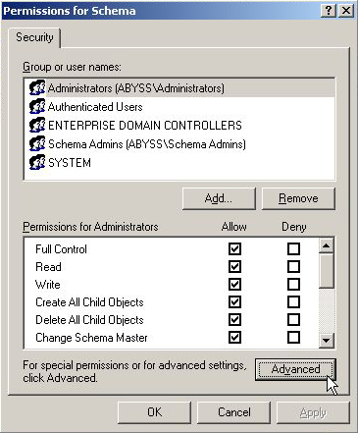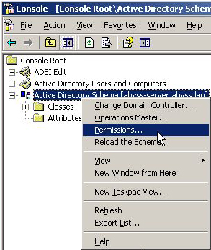

To view Schema Permissions, right click on “Active Directory Schema” in your MMC console and click on “Permissions…”

Here, we decide to grant local Server Administrators rights. So click on him in the Security list and allow to him Full Control.

Then click on “Advanced”.

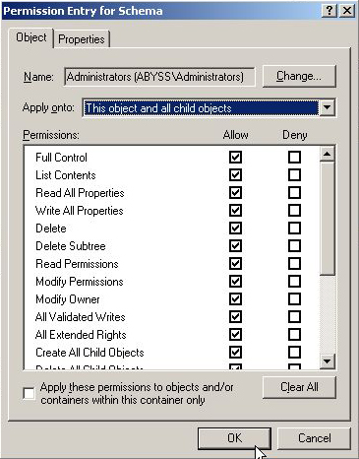

On the “Permissions” tab, select the Local Administrator and click on him.

On the “Permission Entry”, allow Full Control to “This object and all child objects”.

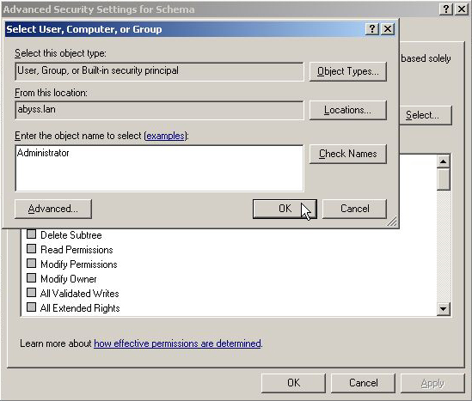

On the “Effective Permissions” tab, search for the Administrator and select the Admin user.

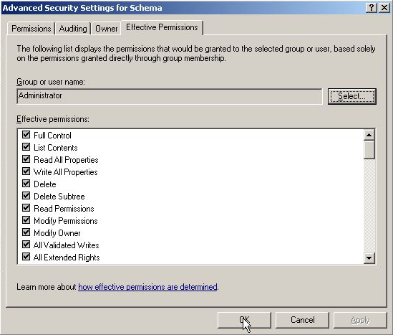

Then, allow him “Full Control”, validate and close the MMC Console.

## Allow Schema Update

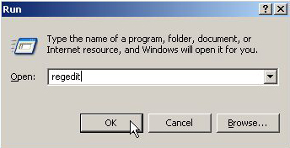

Now, we have to allow Schema Updates.

Launch the Registry Editor: “Start”, “Run…” and enter “regedit”.

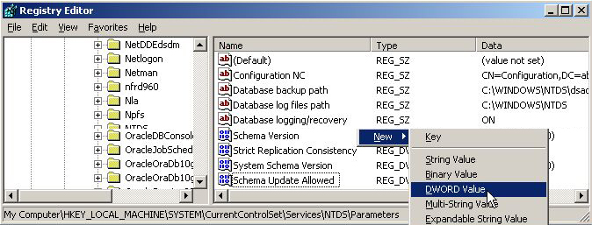

Then, go to “HKEY_LOCAL_MACHINE\SYSTEM\CurrentControlSet\Services\NTDS\Parameters” and create a “DWORD Value” named “Schema Update Allowed”.

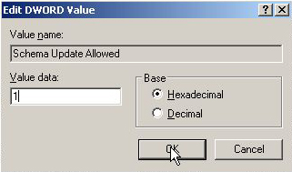

Right click on it to modify it value: 1 in Hexadecimal.

Schema Update is now allowed.

# Active Directory Anonymous Operation

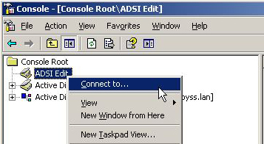

You need to configure Active Directory to allow anonymous operation.

First, launch your MMC Console and right click on ADSI Edit, “Connect to…”

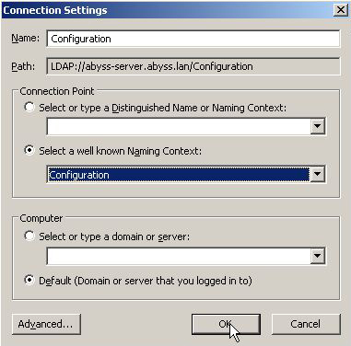

Select “Configuration” as Naming Context and OK.

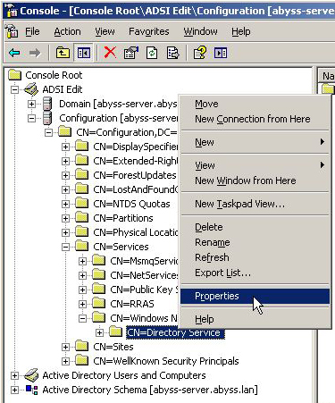

Then, deploy “Configuration”, “CN=Configuration, DC=your_server…”, “CN=Services”, “CN=Windows NT”.

Right click on “CN=Directory Service” and “Properties”.

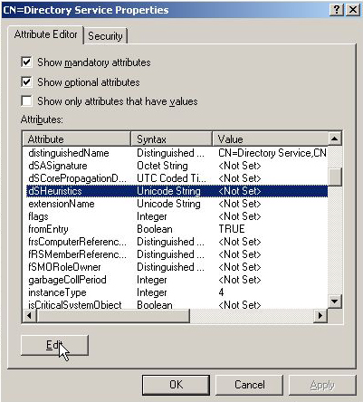

Enter for value: 0000002 (6 x 0 and 2) then OK.

Now, anonymous operations are allowed for Active Directory.

Search on the Attributes list: “dsHeuristics” and click twice on it (or Edit).

You can now modify this value.

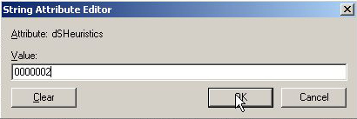

# Oracle Context

## View Advanced Features

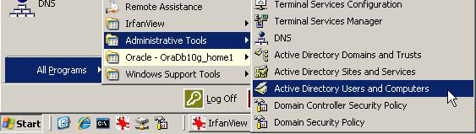

To see all containers, you need to configure on Active Directory Users and Computers.

First, click on start, Administrative Tools and Active Directory Users and Computers

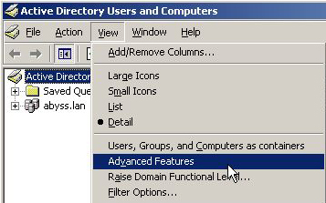

Then open the View tab and click on “Advanced Features”.

Restart and launch the Oracle Context creation.

## Creation

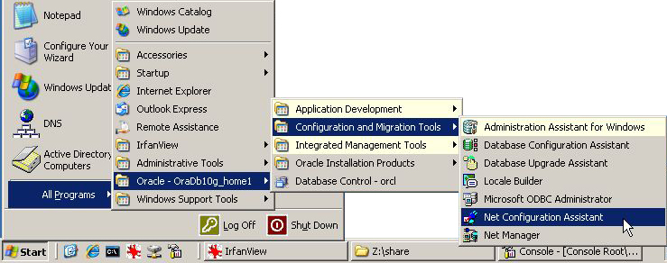

Launch “Net Configuration Assistant” to start the Oracle Context’s installation.

You can found this wizard in “Start”, “All Programs”, “Oracle – OraDb10g_home1”, “Configuration and Migration Tools”, “Net Configuration Assistant”.

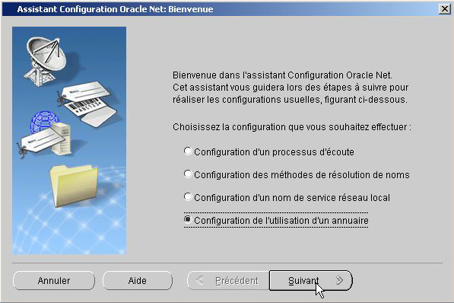

Click on “Directory Service Usage Configuration” and “Next”.

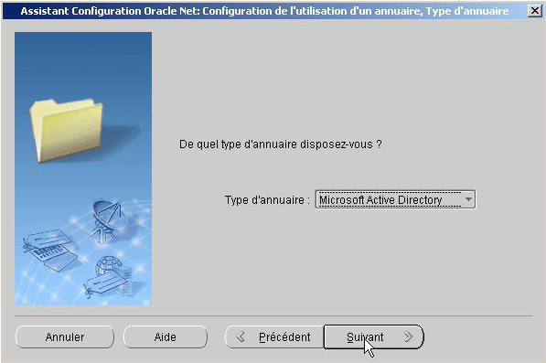

Then, verify that “Microsoft Active Directory” is select, and “Next”.

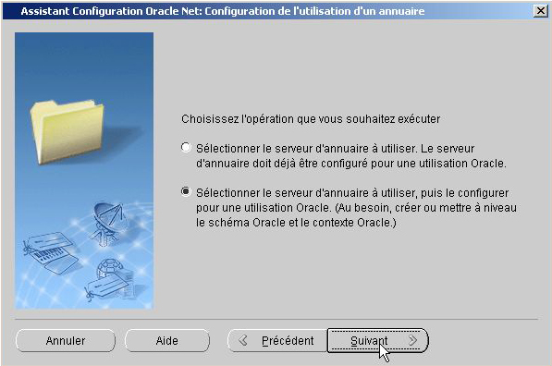

Choice the second proposition to select your “Active Directory Server”.

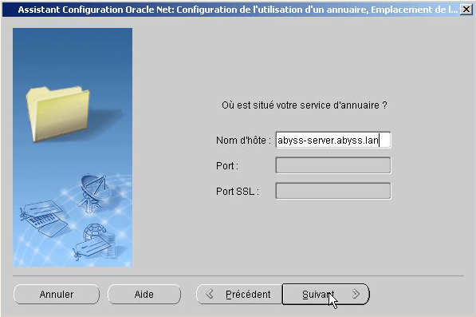

Here, you need to enter your full server name and validate by Next.

The next windows may take time because the wizard tries to connect to your local server.

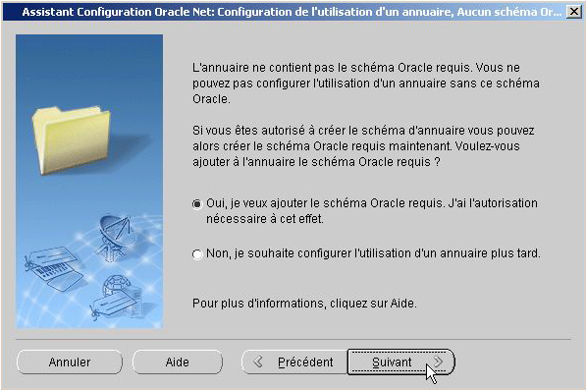

Then, click on the first sentence to add Oracle Schema on Active Directory.

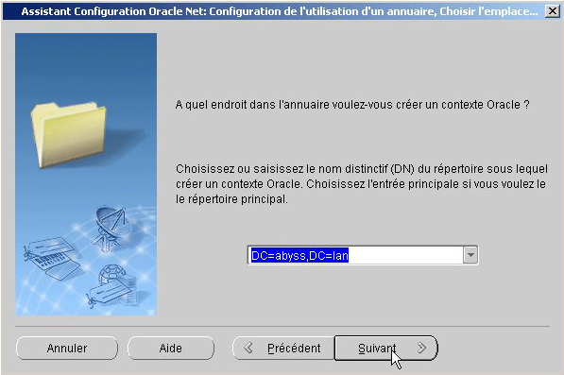

Select where you want create Oracle Context and validate twice to finish the installation.

## Oracle Context’s checkout

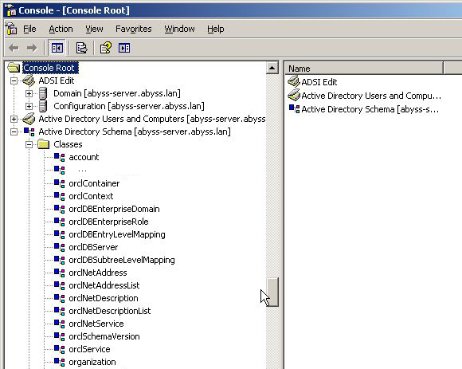

To validate the installation, you can verify if the “Oracle schema” is integrate in the “Active Directory Schema” with your MMC Console.

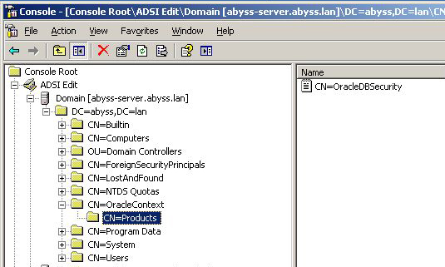

You can also see in ADSI Console (MMC Console) if the Oracle Context is in the Domain.

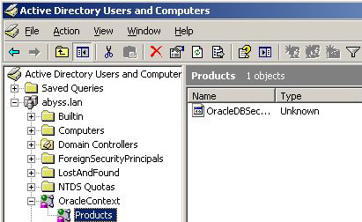

And in “Active Directory User and Computer” you can verify if the Oracle Context is here.

## Administrator rights on Oracle Context

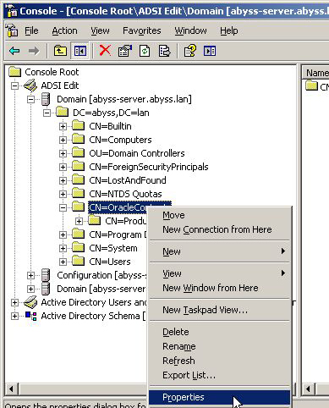

To allow your local Administrator to manage your OracleContext, you need to grant his rights on it.

First, launch your MMC Console, right click on OracleContext in “ADSI Edit Console/Domain/your_domain”, and click on “Properties”.

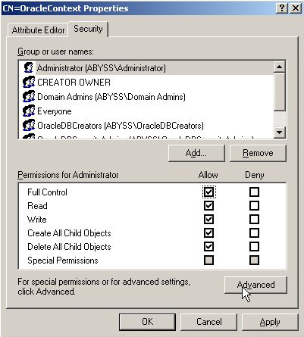

Then, go on the Security tab and search for your local Admin by clicking on “Add…”

When you found him, select your Admin and give him “Full Control” rights.

Then click on Advanced.

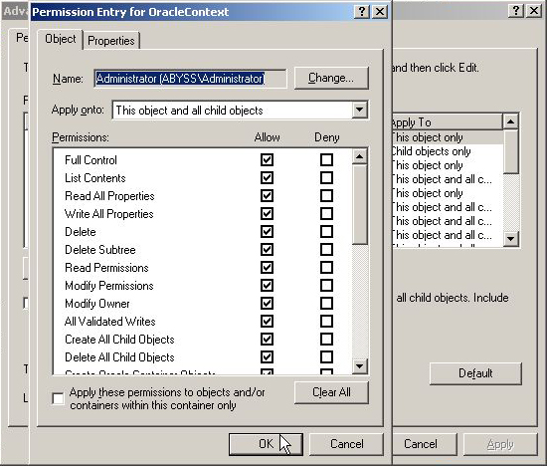

In “Advanced Security Settinggs for OracleContext”, select your local admin in the list and double click on him.

Select “Full Control” and check that “This object and all child objects” is selected.

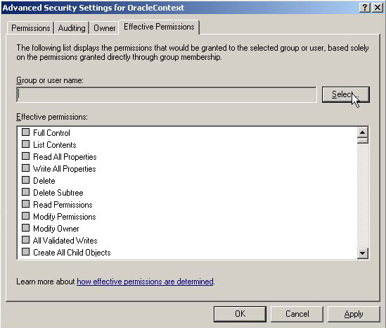

Then validate and go to “Effective Permissions” tab. Select your admin and check that “Full Control” is allowed.

Your local Administrator have now all rights on OracleContext.

## Anonymous Logon on OracleContext

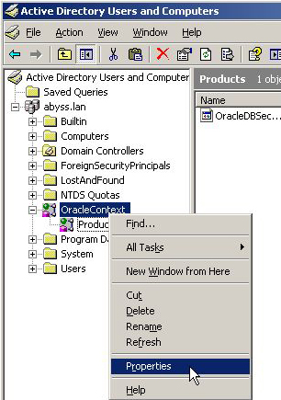

Make a right click on OracleContext and click on “Properties”.

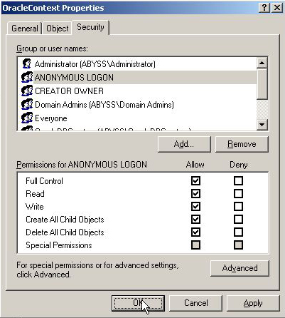

Search for “Anonymous Logon” in the list or “Add…” him and allow him Full Control.

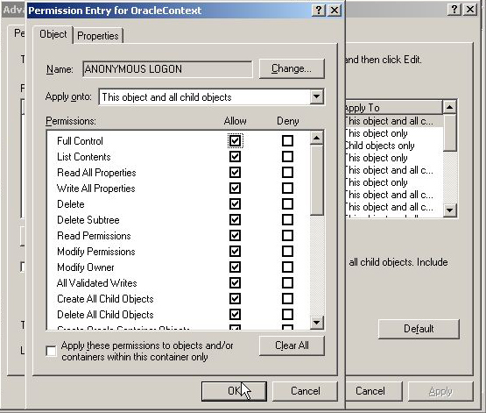

Then validate and go to “Effective Permissions” tab. Select “Anonymous Logon” and check that “Full Control” is allowed.

# ?????

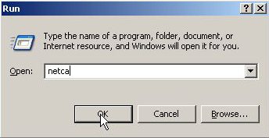

Click on Start, Run and enter “netca” then OK.

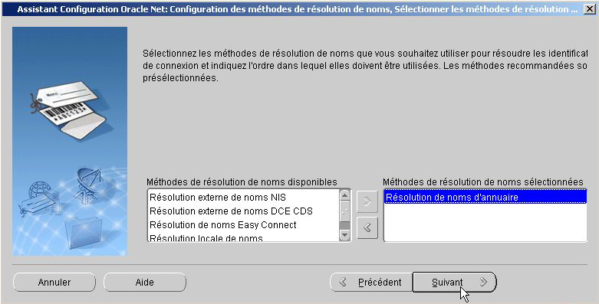

Check that only “Name Directory Resolution” is checked then Next.

# Database Configuration

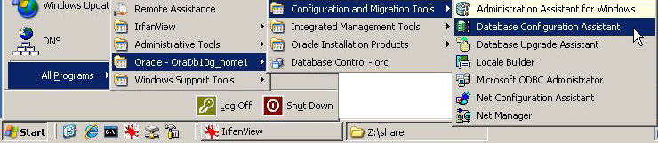

Launch “Database Configuration Assistant” in “Start”, “All Programs”, “Oracle – OraDb10g_home1”, “Configuration and Migration Tools”.

Click twice on OK.

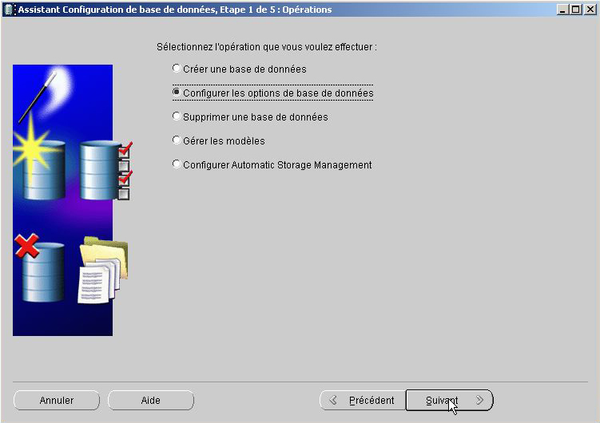

Then click on “Manage Database Options” and Next

Select your Database and click on Next

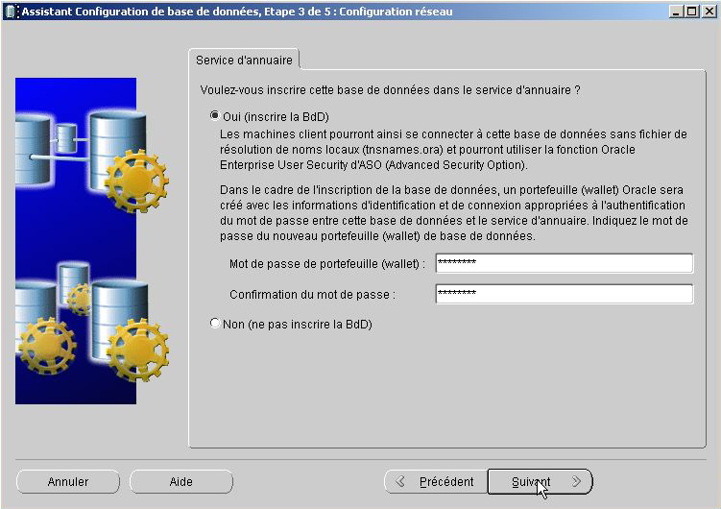

Register your database and enter your password.

Then click twice on Next.

The Configuration Wizard is now finished.

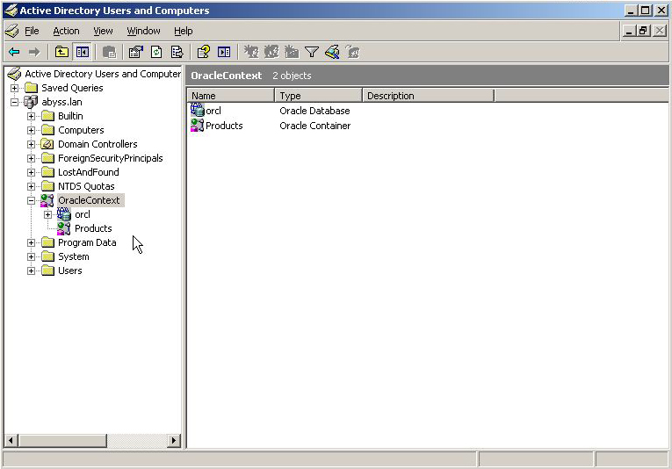

Now you can check on “Active Directory Users and Computers” your database.

See it on “OracleContext”.